LAB 5-U24AI041

Question 1 : Use Employee table from Assignment 2.
- Display the list of employees whose name starts with ‘A’.
Query:
use lab2;
select * from Employee where E_Name like "A%";
Output:
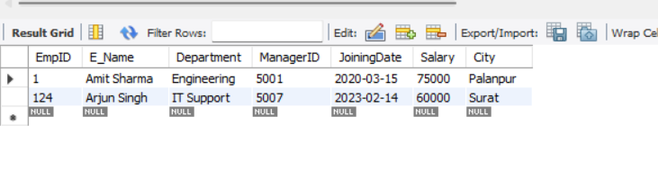b) Add a new column named city and display the list of employees whose city
starts with letter ‘m’.
Query:
alter table Employee add column City varchar(26);
UPDATE Employee SET City = 'Palanpur' WHERE EmpId = 1;
UPDATE Employee SET City = 'Delhi' WHERE EmpId = 12;
UPDATE Employee SET City = 'Mumbai' WHERE EmpId = 100;
UPDATE Employee SET City = 'Kolkata' WHERE EmpId = 104;
UPDATE Employee SET City = 'Madhyapradesh' WHERE EmpId = 005;
UPDATE Employee SET City = 'Hyderabad' WHERE EmpId = 006;
UPDATE Employee SET City = 'Surat' WHERE EmpId = 124;
UPDATE Employee SET City = 'Jaipur' WHERE EmpId = 108;
UPDATE Employee SET City = 'Pune' WHERE EmpId = 029;
UPDATE Employee SET City = 'Bengaluru' WHERE EmpId = 101;

select * from Employee where City like "M%";

Output:

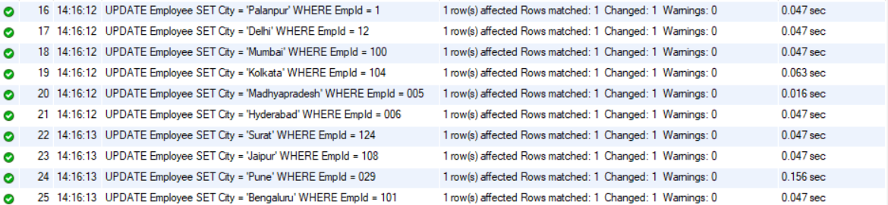
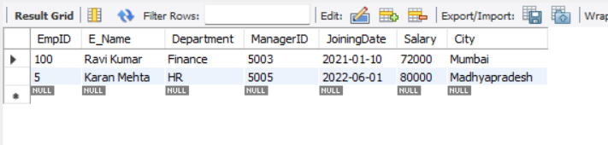
c) Display the list of employees whose city ends with word ‘pradesh’.
Query:
select* from Employee where city like '%pradesh';
Output:
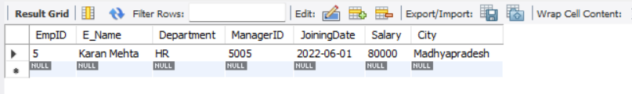
d) Display the list of employees who are having exactly five characters in their
name.
Query:
select* from Employee where E_name like '_____';
Output:
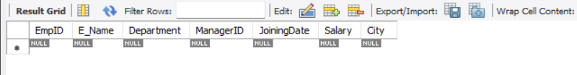

e) Display the list of employees whose city is having only five characters.
Query:
select* from Employee where city like '_____';

Output:
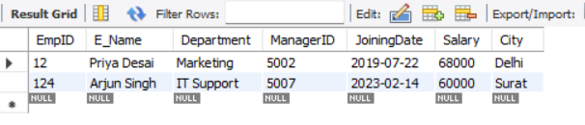
f) Find the names of employees whose name includes the substring “man”.
Query:
select* from Employee where E_name like '%man%';

Output:
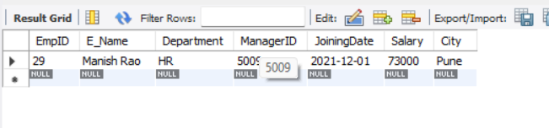
Question 2 :Use Student table from Assignment 2.
- Display the list of students whose name starts with ‘M’.
Query:
select* from Student where s_name like 'N%';
Output:
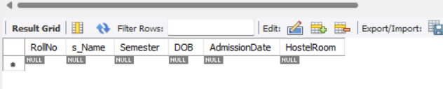
b) Add a new column named branch and display the list of employees whose
branch starts with letter ‘A’
Query:
alter table Student add column Branch varchar(26);
UPDATE Student SET Branch = 'Information Technology' WHERE RollNo = 121;
UPDATE Student SET Branch = 'Mechanical' WHERE RollNo = 170;
UPDATE Student SET Branch = 'Electrical' WHERE RollNo = 113;
UPDATE Student SET Branch = 'Computer Science' WHERE RollNo = 104;
UPDATE Student SET Branch = 'Civil' WHERE RollNo = 205;
UPDATE Student SET Branch = 'Electronics' WHERE RollNo = 606;
UPDATE Student SET Branch = ' Artificial Intelligence' WHERE RollNo = 07;
UPDATE Student SET Branch = 'Chemical' WHERE RollNo = 870;
UPDATE Student SET Branch = 'Biomedical' WHERE RollNo = 199;
UPDATE Student SET Branch = 'Aerospace' WHERE RollNo = 100;
select * from Student where Branch like "A%";

Output:
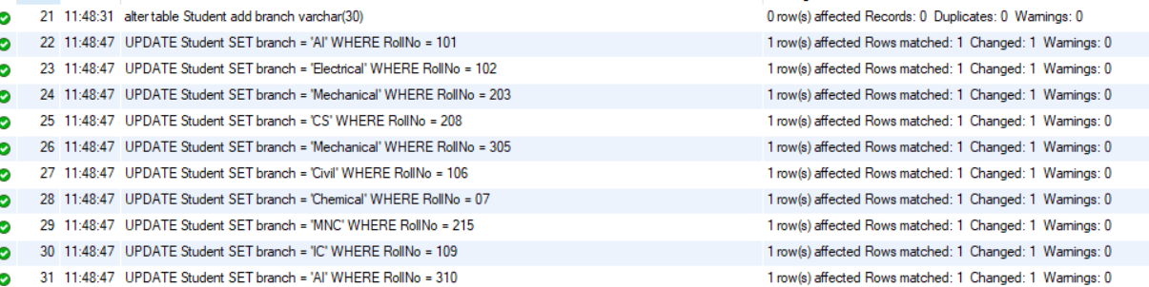
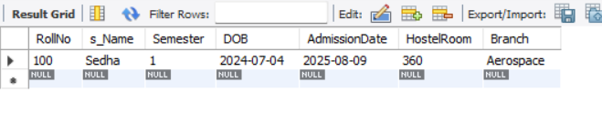

c) Display the list of students who are having exactly five characters in their name.
Query:
select* from Student where s_name like '_____';

Output:
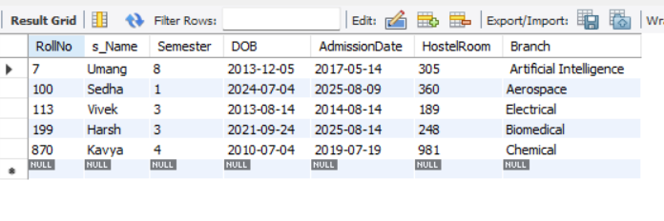

d) Add a new column named city and display the list of students whose city is
having only ten characters.
Query:
alter table Student add city varchar(30);
UPDATE Student SET city = 'Palanpur' WHERE RollNo = 101;
UPDATE Student SET city = 'Unjha' WHERE RollNo = 102;
UPDATE Student SET city = 'Surat' WHERE RollNo = 203;
UPDATE Student SET city = 'Ahmedabad' WHERE RollNo = 208;
UPDATE Student SET city = 'Mehsana' WHERE RollNo = 305;
UPDATE Student SET city = 'Gandhinagar' WHERE RollNo = 106;
UPDATE Student SET city = 'Uttarpradesh' WHERE RollNo= 07;
UPDATE Student SET city = 'Navsari' WHERE RollNo = 215;
UPDATE Student SET city = 'Bharuch' WHERE RollNo = 109;
UPDATE Student SET city = 'Baroda' WHERE RollNo = 310;
select* from Student where city like '__________';

Output:
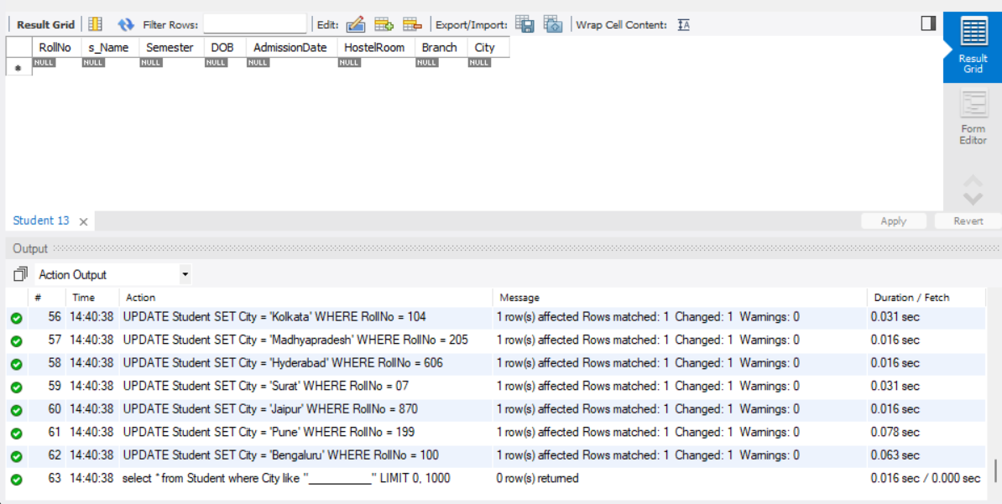

e) Find the names of students whose name includes the substring “sh”.
Query:
select* from Student where s_name like '%sh%';

Output:
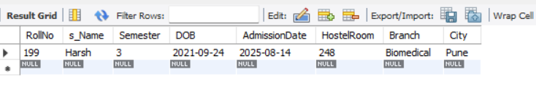

Question 3 : Create table Customers with this schema: (CustomerID, CustomerName,
ContactName, Address, City, PostalCode, Country)
Query:
use lab5;
create table Customers(
CustomerID varchar(50) primary key,
CustomerName varchar(65),
ContactNo int(10),
Address text (100),
City varchar(19),
PostalCode int(6),
Country varchar (10)
);
INSERT INTO Customers
(CustomerID, CustomerName, ContactNo, Address, City, PostalCode, Country)
VALUES
(1, 'Amit Sharma', 1545145178,'12 Industrial Area', 'Delhi', '110001', 'India'),
(2, 'Priya Mehta', 1545145151,'45 Garden Street', 'Mumbai', '400002', 'India'),
(3, 'Rimsat Verma', 1545121451,'88 Tower Road', 'Bengaluru', '560001', 'India'),
(4, 'Neha Patel', 1577145178,'23 Marine Drive', 'Surat', '395003', 'India'),
(5, 'Karan Singh', 9997145178,'101 Market Lane', 'Kolkata', '700001', 'India'),
(6, 'Umangbhai patel', 1500005178,'101 Market Lane', 'Madhya Pradesh', '700801', 'India')
;

- Return all customers that ends with the pattern 'bhai'.
Query:
select* from Customers where CustomerName like '%bhai';

Output:
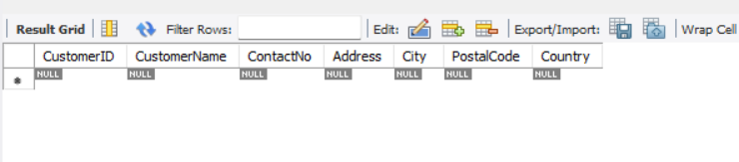

- Return all customers that contains the pattern 'sat'.
Query:
select* from Customers where CustomerName like '%sat%';

Output:
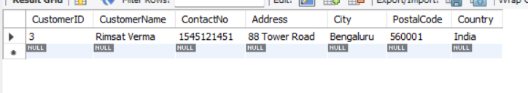

c) Return all customers with a city starting with any character, followed by
"pradesh".
Query:
select* from Customers where City like '%pradesh';

Output:
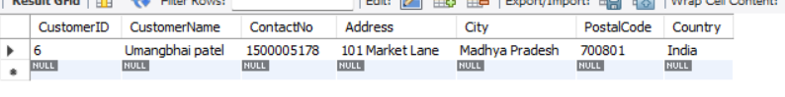

d) Return all customers with a city starting with "S", followed by any four
characters, ending with "at".
Query:
select* from Customers where City like 'S__at';

Output:
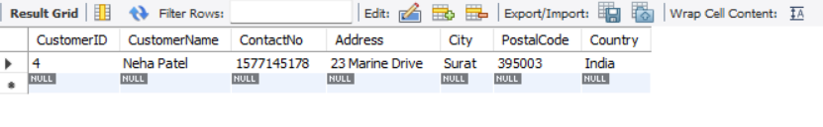

e) Return all customers from Mumbai.
Query:
select* from Customers where City='Mumbai';

Output:
